Purpose:

* The purpose of this procedure is to instruct the user on how to re-torque the flange screws on the Shallow Pump. It details the steps necessary to gain straight-line access to these screws, which is absolutely necessary to avoid galling of the screwheads

Tools and Materials Required:

* 50 Inch-Pound Torque Wrench
* 5/32” Allen Bit, not a ball end!
* 1/4” drive 6” Rachet Extension, Qty. 2
* 1/8” Allen “T” handle driver
* 5/16” Nutdriver
* #1 Phillips Screwdriver
* Blue Loctite # 243
* Heat Gun, ***might be required if Loctite kicked too hard on mounting screws***

1. Remove the desiccant bag (if present). Remove the ballast weights using the 1/8” T handle Allen. Note: Mark Red for Port and Green for Starboard. Don’t mix them! Remove both P&S. Remove the Flat Head screws using the 1/8” T-handle Allen.

Figure 1 Port Side Ballast Weights and Bracket

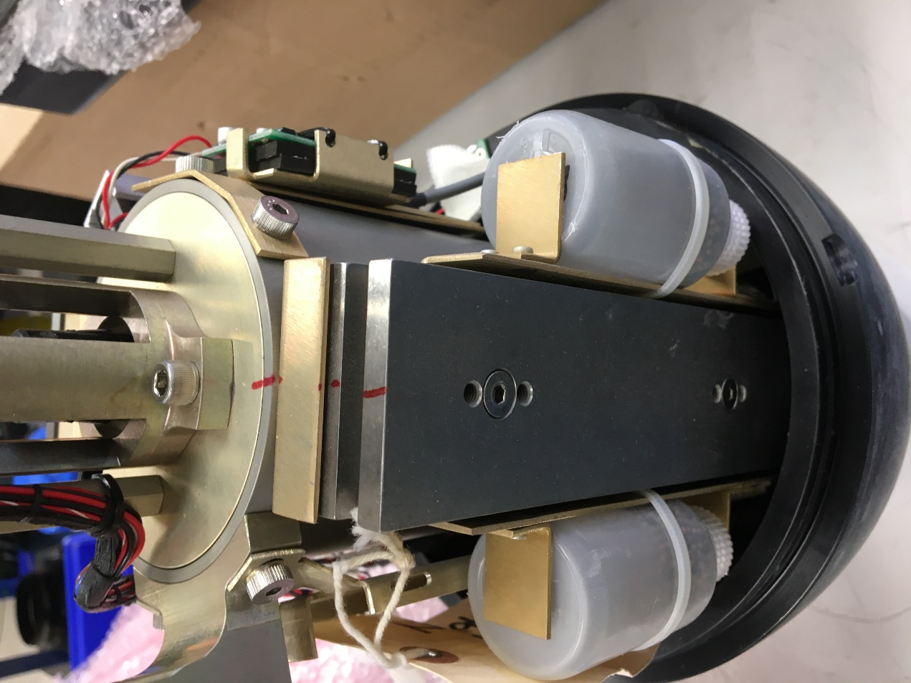

1. Remove the Shoulder Screw from the top of the Ballast Bracket(s) to the Piston Housing using the 1/8” T handle Allen. This will allow you to tilt the bracket(s) for direct access to the flange screw(s).

Figure 2 Ballast Bracket with weights removed

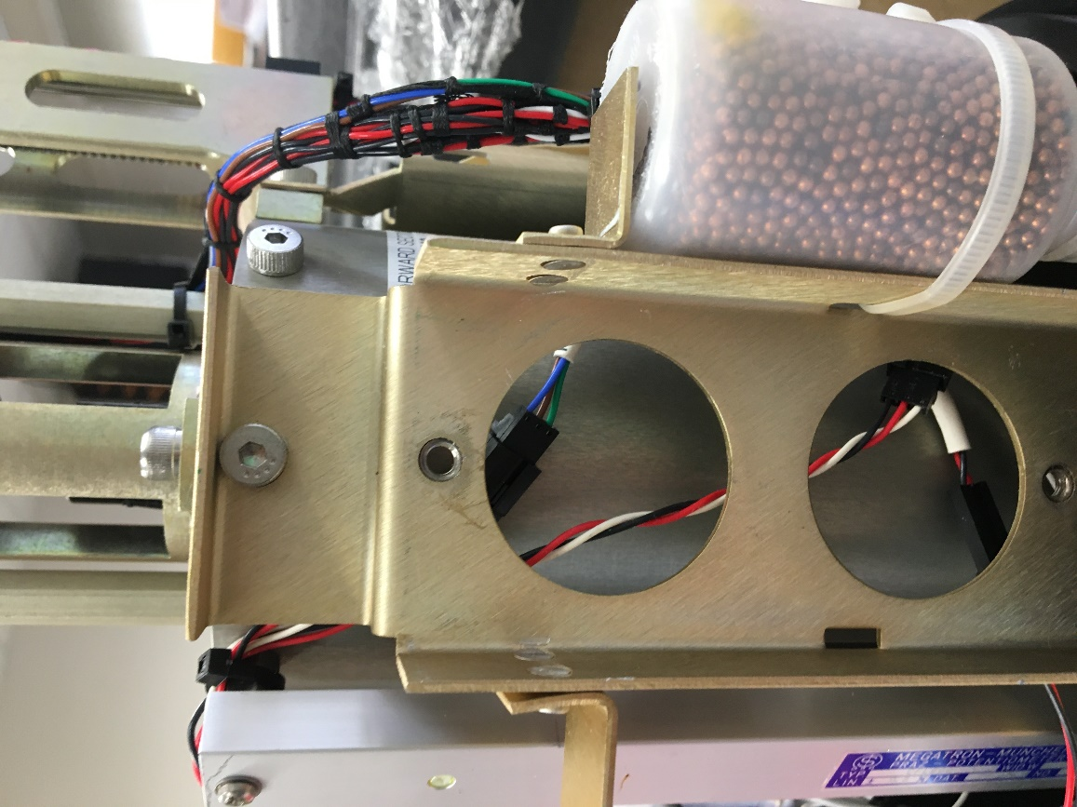

1. Remove the Pitch Motor: Remove the Shoulder Screws from the Pitch Motor using the 1/8” T handle and remove the Pitch Motor (Note: these screws are 7/8” long). There should be enough slack in the wires, so you don’t need to disconnect them. Disconnect if not the case. This again will allow you to tilt this bracket for direct access to the flange screws.

Figure 3 Pitch Motor

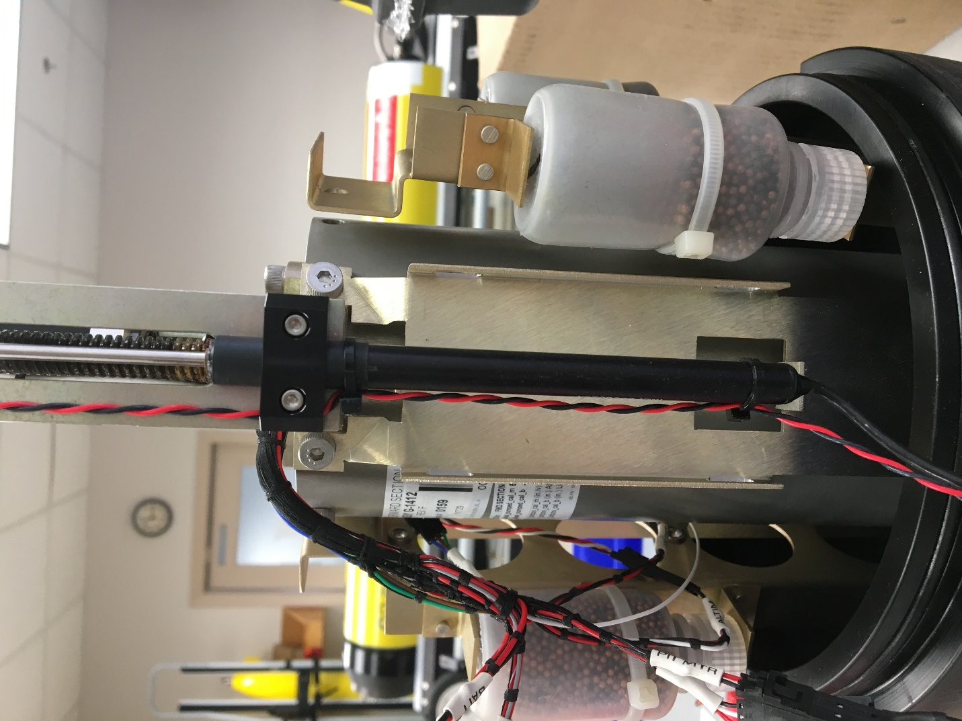

Figure 4 Pitch Motor removed

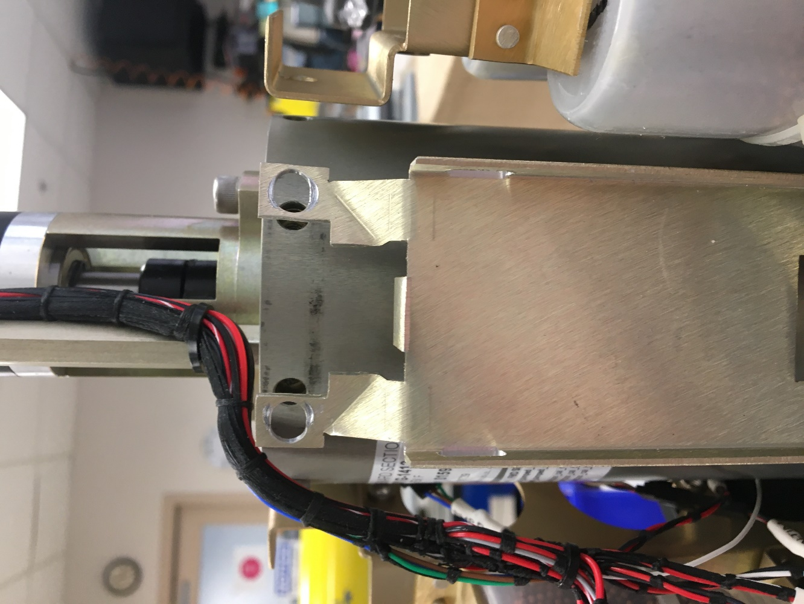

1. Remove the #4-40 Philips sems screw from the top of the potentiometer, tilt the potentiometer toward you slightly, then tilt to the left. The base of the potentiometer sits on a mating bracket on the flange. Observe the slider on the potentiometer and the mating bracket on the Piston Cylinder. Try not to move the slider.

Figure 5

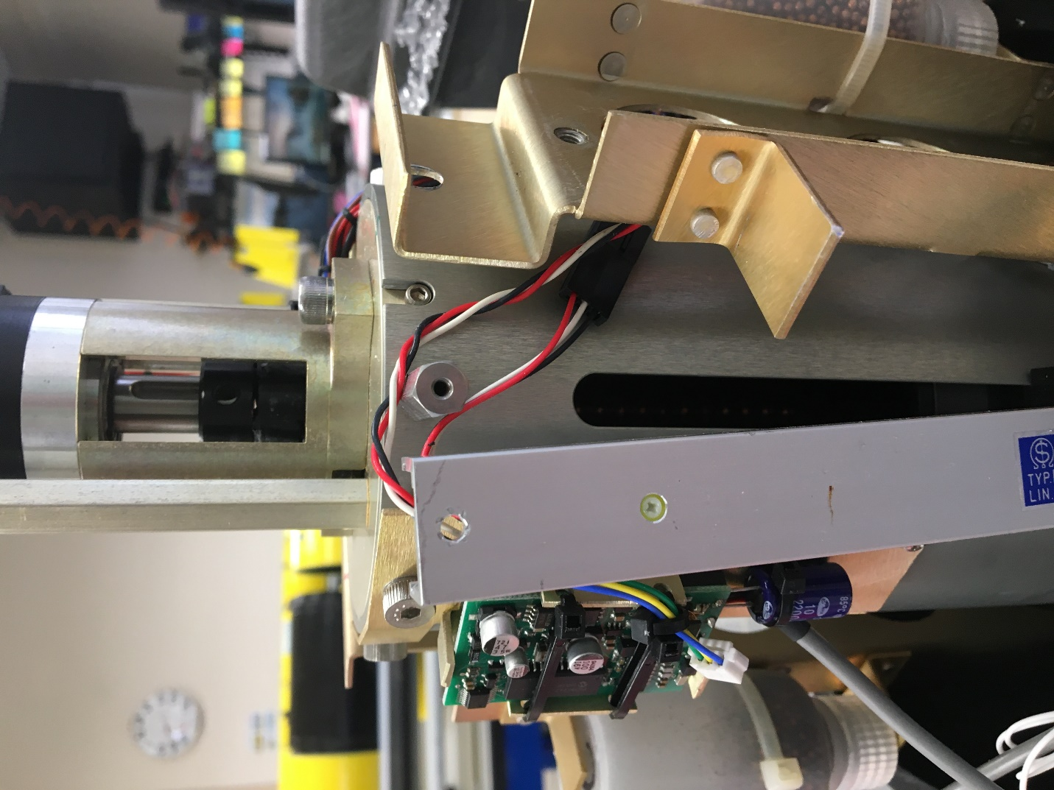

1. Remove the 5/16” standoff with a 5/16” nut driver, this will also allow straight access to the flange screw. If there is any Loctite dust, on the potentiometer coupling, blow it off.

Figure 6

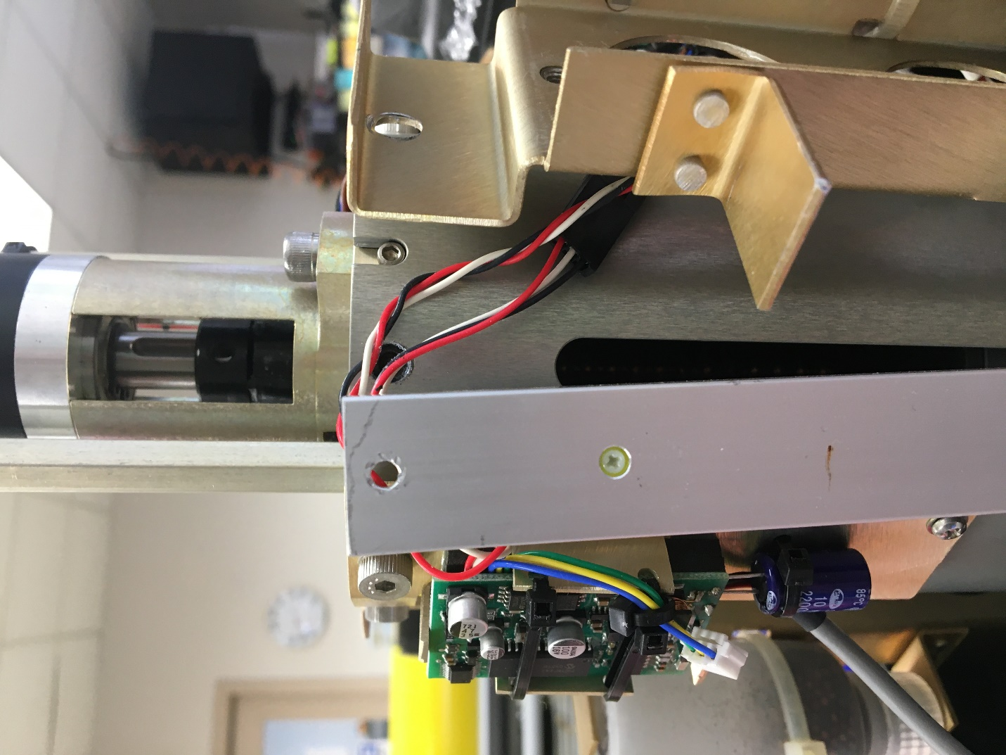

1. Remove the Altimeter Bracket: Remove the two Shoulder Screws from the Altimeter Bracket using the 1/8” T handle and remove the Altimeter Bracket, set it on top of the housing (figure 8). This again will ensure that the Altimeter board does not get damaged.

Figure 7

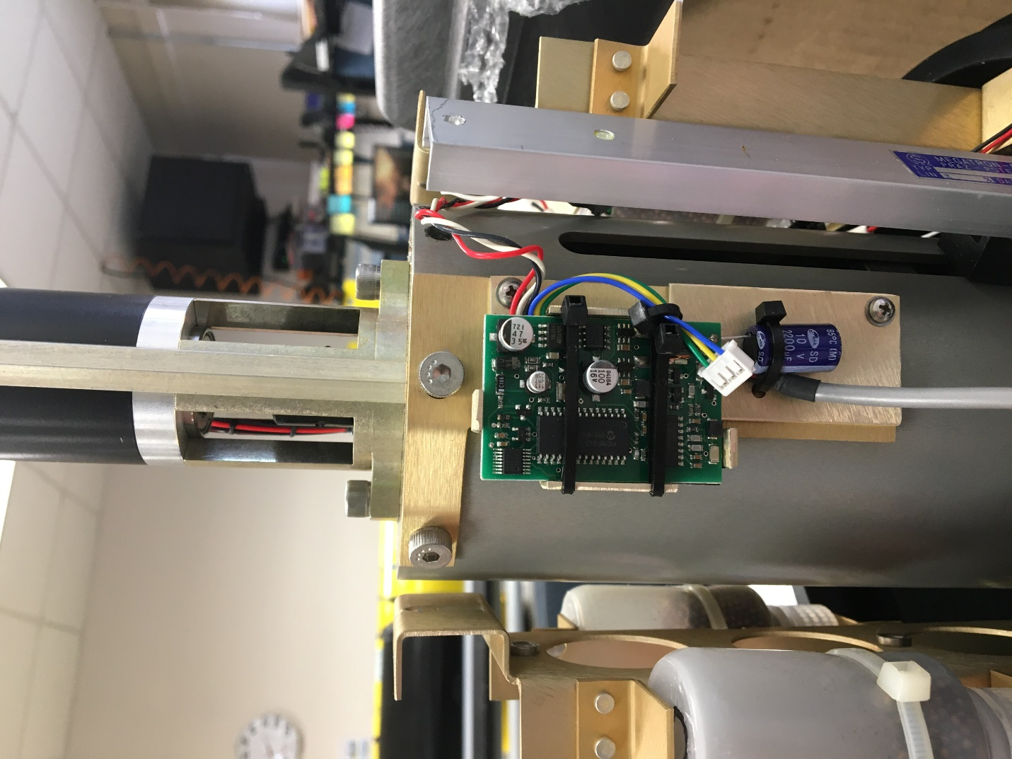

Figure 8

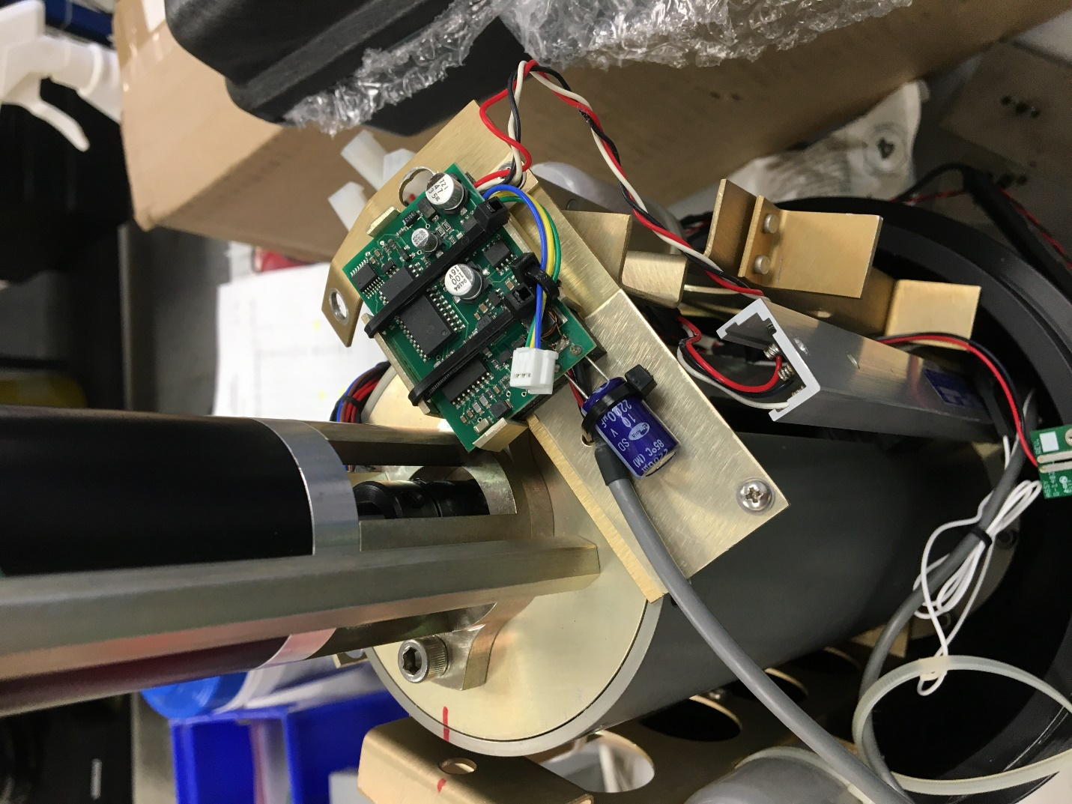

1. This is the SAE standard 8-bolt flange torque pattern. You can choose any flange screw as #1. With the 50-inch pound torque wrench, rachet extensions and 5/32” bit, torque the screws. You will do this twice. The second pass you will select another #1 position.

Figure 9

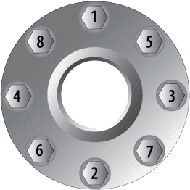

Figure 10

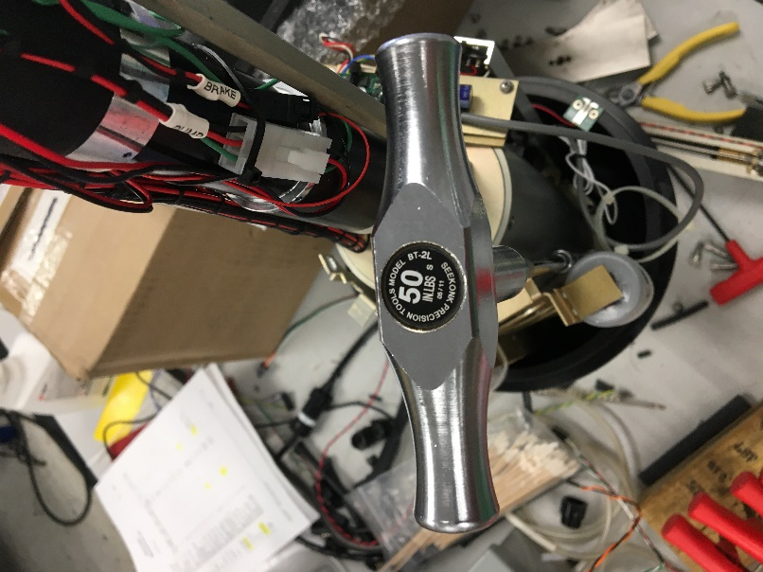

1. Re-install the 5/16” standoff. Use a small amount of Blue Loctite 243 on the threads. Guide the Potentiometer back in place, making certain the slider engages fully. Fasten with the #4-40 Phillips sems screw.
2. Re-install the Altimeter bracket with the two Shoulder Screws using a small amount of Blue Loctite 243 on the threads. Use the 1/8” T handle allen.
3. Re-install the Altimeter bracket with the two Shoulder Screws using a small amount of Blue Loctite 243 on the threads. Use the 1/8” T handle allen.
4. Re-install the Pitch Motor with the two 7/8” Shoulder Screws using a small amount of Blue Loctite 243 on the threads. Use the 1/8” T handle allen. Tip: install the first Shoulder screw just a thread or two, then the other one. The assembly is on a radius and if you tighten the first too much, you can’t get the second to thread. Reconnect the wires if you disconnected them.
5. Re-attach the Starboard Ballast bracket with a Shoulder Screw using a small amount of Blue Loctite 243 on the threads. Use the 1/8” T handle allen. Make sure the wires for the Potentiometer and altimeter DO NOT get pinched between the bracket and Piston Housing.
6. Re-attach the Port Ballast bracket with a Shoulder Screw using a small amount of Blue Loctite 243 on the threads. Use the 1/8” T handle allen.
7. Re-install the Port and Starboard Ballast Weights using the flat head screws in the same configuration they came off. DO NOT use Loctite on the first two weights per side. Use a small amount of Loctite 243 on the outer screws only.

End of Instruction